**Linux Assignment -4**

1. Using while loop print the tables like 2*1=2 etc…

**Program: -**

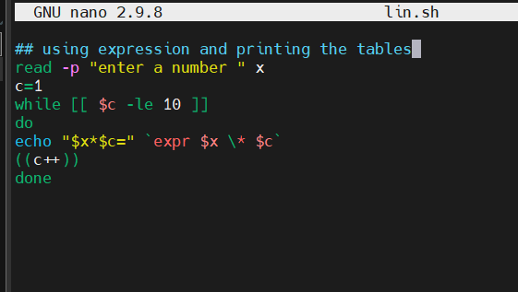

**Output: -**

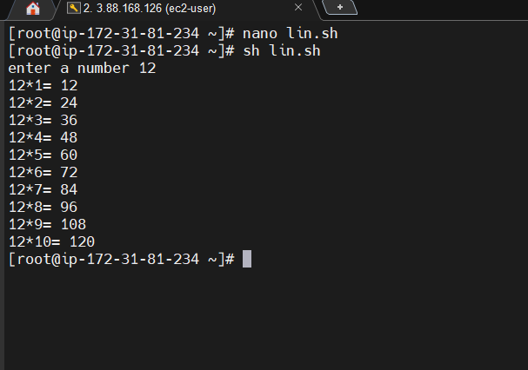

1. using if-else when the condition is true then it needs print the even numbers?

**Program:-**

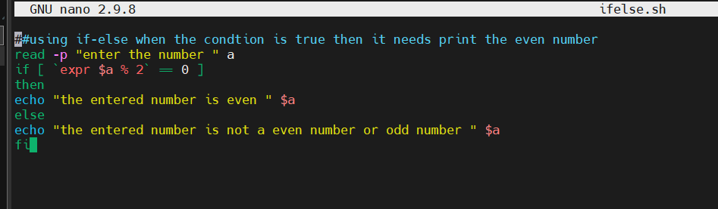

**Output: -**

